Recommender systems
第一单元collaborative filtering
1.You have the following table of movie ratings:
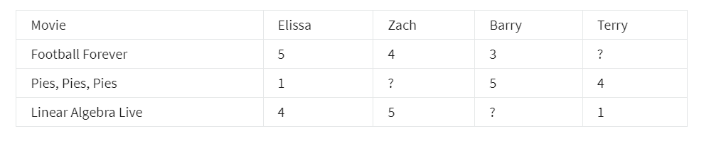
Refer to the table above for question 1 and 2. Assume numbering starts at 1 for this quiz, so the rating for Football Forever by Elissa is at (1,1)
What is the value of nu​​

2.What is the value of r(2,2)

- In which of the following situations will a collaborative filtering system be the most appropriate learning algorithm (compared to linear or logistic regression)?

You subscribe to an online video streaming service, and are not satisfied with their movie suggestions. You download all your viewing for the last 10 years and rate each item. You assign each item a genre. Using your ratings and genre assignment, you learn to predict how you will rate new movies based on the genre.

You're an artist and hand-paint portraits for your clients. Each client gets a different portrait (of themselves) and gives you 1-5 star rating feedback, and each client purchases at most 1 portrait. You'd like to predict what rating your next customer will give you.

You run an online bookstore and collect the ratings of many users. You want to use this to identify what books are "similar" to each other (i.e., if a user likes a certain book, what are other books that they might also like?)

You manage an online bookstore and you have the book ratings from many users. You want to learn to predict the expected sales volume (number of books sold) as a function of the average rating of a book.

4.For recommender systems with binary labels y, which of these are reasonable ways for defining when y should be 1 for a given user j and item i? (Check all that apply.)

y is 1 if user j purchases item i (after being shown the item)

y is 1 if user j fav/likes/clicks on item i (after being shown the item)

y is 1 if user j has been shown item i by the recommendation engine

y is 1 if user j has not yet been shown item i by the recommendation engine

第二单元Recommender systems implementation detail
1.Lecture described using ‘mean normalization’ to do feature scaling of the ratings. What equation below best describes this algorithm?

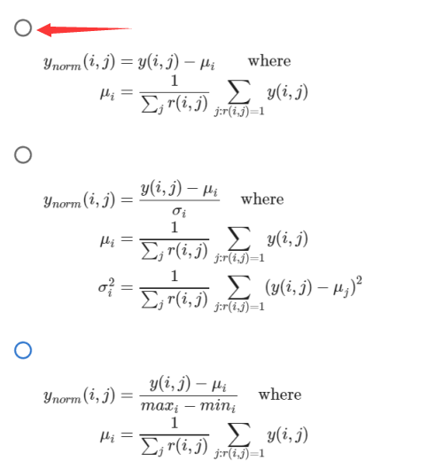
- The implementation of collaborative filtering utilized a custom training loop in TensorFlow. Is it true that TensorFlow always requires a custom training loop?

Yes. TensorFlow gains flexibility by providing the user primitive operations they can combine in many ways.

No: TensorFlow provides simplified training operations for some applications.

- Once a model is trained, the 'distance' between features vectors gives an indication of how similar items are.
The squared distance between the two vectors x(k) and x(i) is:
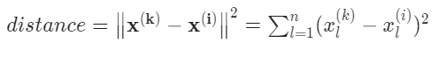
Using the table below, find the closest item to the movie "Pies, Pies, Pies".
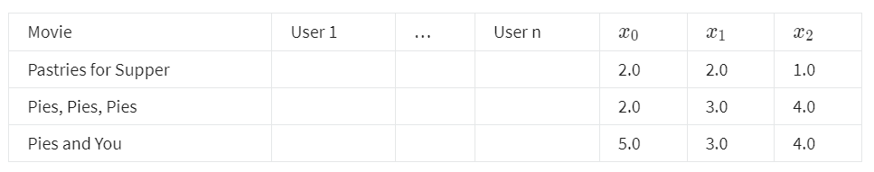
Pies and You

Pastries for Supper

- Which of these is an example of the cold start problem? (Check all that apply.)

A recommendation system is unable to give accurate rating predictions for a new product that no users have rated.

A recommendation system is unable to give accurate rating predictions for a new user that has rated few products.

A recommendation system is so computationally expensive that it causes your computer CPU to heat up, causing your computer to need to be cooled down and restarted.

A recommendation system takes so long to train that users get bored and leave.

第三单元content-based filtering
1.Vector xu​ and vector xm​ must be of the same dimension, where xu​ is the input features vector for a user (age, gender, etc.) xm​ is the input features vector for a movie (year, genre, etc.) True or false?

True

False

- If we find that two movies, i and k, have vectors vm(i)​ and vm(k)​ that are similar to each other (i.e., ∣∣vm(i)​−vm(k)​∣∣ is small), then which of the following is likely to be true? Pick the best answer.

The two movies are very dissimilar.

A user that has watched one of these two movies has probably watched the other as well.

The two movies are similar to each other and will be liked by similar users.

We should recommend to users one of these two movies, but not both.

- Which of the following neural network configurations are valid for a content based filtering application? Please note carefully the dimensions of the neural network indicated in the diagram. Check all the options that apply:

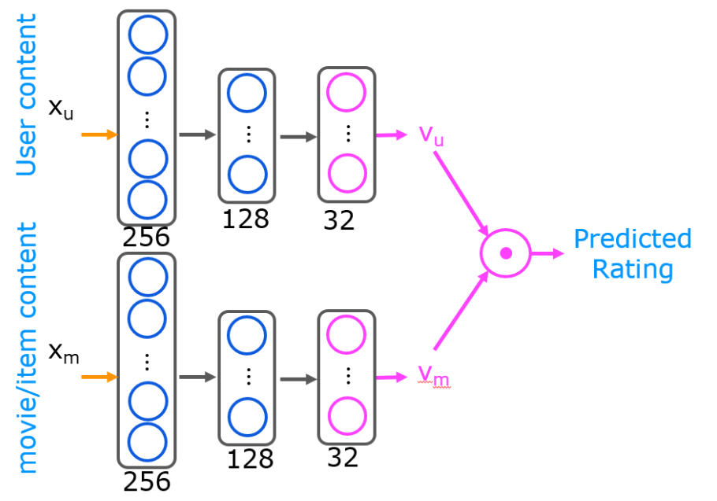
Both the user and the item networks have the same architecture

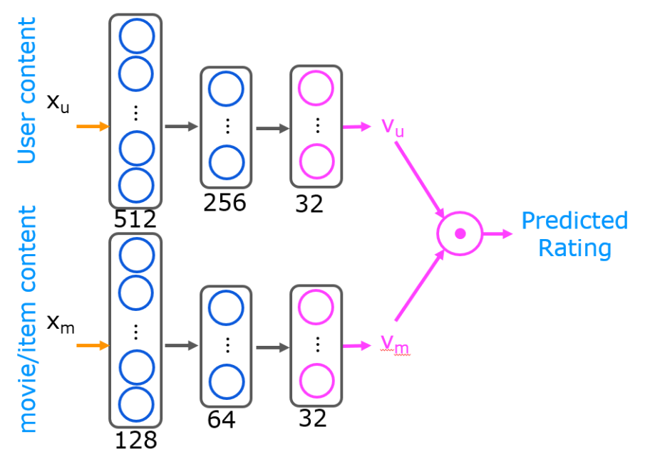
The user and the item networks have different architectures

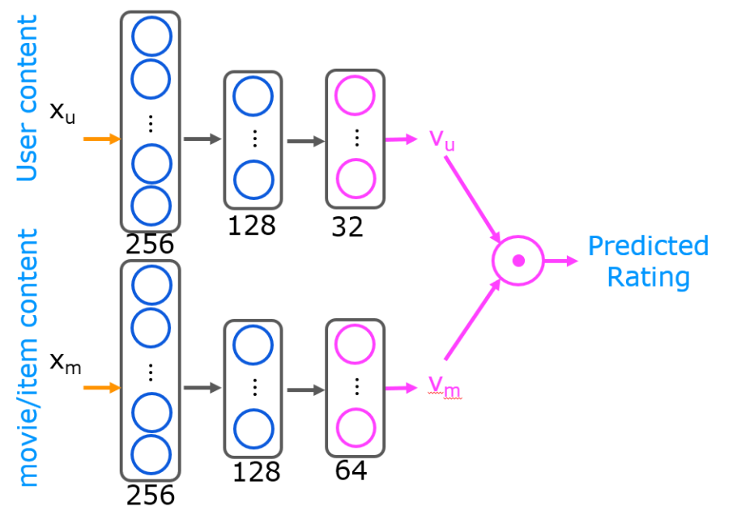
The user vector v_u is 32 dimensional, and the item vector v_m is 64 dimensional

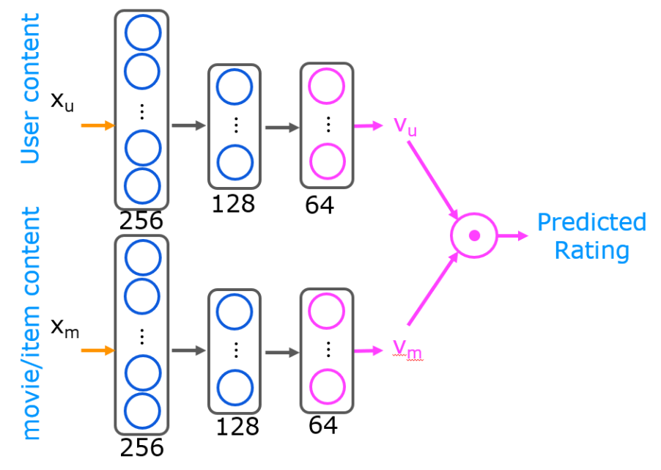
The user and item networks have 64 dimensional v_u and v_m vector respectively

- You have built a recommendation system to retrieve musical pieces from a large database of music, and have an algorithm that uses separate retrieval and ranking steps. If you modify the algorithm to add more musical pieces to the retrieved list (i.e., the retrieval step returns more items), which of these are likely to happen? Check all that apply.

The quality of recommendations made to users should stay the same or worsen.

The system’s response time might increase (i.e., users have to wait longer to get recommendations)

The system’s response time might decrease (i.e., users get recommendations more quickly)

The quality of recommendations made to users should stay the same or improve.

- To speed up the response time of your recommendation system, you can pre-compute the vectors v_m for all the items you might recommend. This can be done even before a user logs in to your website and even before you know the xu​ or vu​ vector. True/False?

True

False

